OpCon ServiceNow Application

User Guide

# Disclaimer

No Support and No Warranty are provided by SMA Technologies for this project and related material. The use of this project's files is on your own risk.

SMA Technologies assumes no liability for damage caused by the usage of any of the files offered here via this Github repository.

#### Table of Contents

Disclaimer 2

General Information 4

Components 4

Process 5

Installation 8

Supported Software Levels and Requirements 8

OpCon ServiceNow Application 8

SMA OpCon Connector 8

Installation 8

Figure 1 : OpCon ServiceNow Connector Components 4

Figure 2 : ServiceNow Connector Overview 5

Figure 3 : Previous ticket number added to restart failures 6

Figure 4 : Job Information example showing ServiceNow Incident number 6

Figure 5 : ServiceNow example created Incident 7

Figure 6 : Loading Application using System Update Sets 8

Figure 7 : Uploading Application File 8

Figure 8 : Loaded Application on Retrieved Update Sets List 9

Figure 9 : ServiceNow SMA OpCon Application Information 9

Figure 10 : Update Set Preview success 9

Figure 11 : Commit Update Set 10

Figure 12 : Installed OpConAPI Business Rules 10

Figure 13 : Setting Business Rule to Active state. 10

Figure 14 : Select updateJobStatusByJobId Rest Message 11

Figure 15 : updateJobStatusByJobId REST Message 11

Figure 16 : Updating the Authentication header attribute 11

# General Information

The OpCon ServiceNow Application is a component of the SMA OpCon ServiceNow Connector. It provides the mechanism to submit requests to OpCon using business rules and rest messages when the incident is updated.

The OpCon ServiceNow Connector can be used to submit incident tickets automatically to ServiceNow from OpCon when a task has an error condition. When the incident ticket is accepted in ServiceNow (State moved to In Progress) the task state in OpCon can automatically be changed to Under Review indicating that the error is being worked on. When the error is corrected and the ticket in ServiceNow state changes to Resolved, the task state in OpCon can be changed to either Fixed or Restart. If the ticket in ServiceNow is cancelled, the OpCon task can be automatically cancelled.

## Components

The OpCon ServiceNow implementation includes components that detect when a task errors, create the ServiceNow Incident record (includes adding task job log) and automatically update the OpCon task status when the Incident record Status changes.



Figure 1 : OpCon ServiceNow Connector Components

* Notification Manager An OpCon feature that initiates the ServiceNow Connector

when a task encounters an error condition.

* Windows Agent An OpCon Windows Agent that is used to execute the

ServiceNow connector.

* ServiceNow Connector An OpCon connector that communicates with ServiceNow

through the ServiceNow Rest-API to create an incident.

* Business Rules Part of a ServiceNow OpCon application that contains business

Rules that are triggered when the Status of the incident ticket is updated.

*OpConTicketAccepted*

*OpConTicketResolved*

*OpConTicketRelease*

*OpConTicketCanceled*

* Outbound Rest Messages Part of a ServiceNow OpCon application that contains

Outbound Rest Messages to communicate with OpCon

Through the OpCon Rest-API. This includes messages to update the task status as well as additional messages that can be used by other ServiceNow applications to issue instructions to OpCon.

* *updateJobStatusById*
* *buildSchedule*
* *getDailyScheduleByNameAndDate*
* *addJobToScheduleInDaily*
* *getApiVersion*

## Process

The ticket creation process consists of the following steps.



Figure 2 : ServiceNow Connector Overview

1. The ServiceNow Connector is executed by the Notification Manager when a failed task is detected. The Notification Manager uses the following standard OpCon properties to pass information to the ServiceNow Connector.

* $MACHINE NAME The name of the Agent on which the task was executing.
* $JOB TERMINATION The termination code of the task.
* $SCHEDULE DATE-SNOW A special version of the Schedule Date format created to

support ServiceNow Connector.

* $SCHEDULE ID The schedule ID of the workflow in the OpCon System.
* $SCHEDULE INST The schedule instance of the workflow in the Daily OpCon

table.

* $SCHEDULE NAME The name of the workflow.
* $JOB NAME The name of the task.

1. Before creating a new incident ticket, the ServiceNow Connector checks to see if an incident ticket has already been created for the task. The task information is extracted from the OpCon Daily Job table.
2. If an incident ticket exists, the existing incident ticket is retrieved from ServiceNow and a check is made to see if the incident ticket state is *closed* or *canceled*. If the incident ticket is either *closed* or *canceled*, a new ticket is created. The previous ticket number is attached to the task documentation and the incident ticket description. Otherwise the ticket is updated reflecting the new task error information and the is re-opened (state set to *New*).

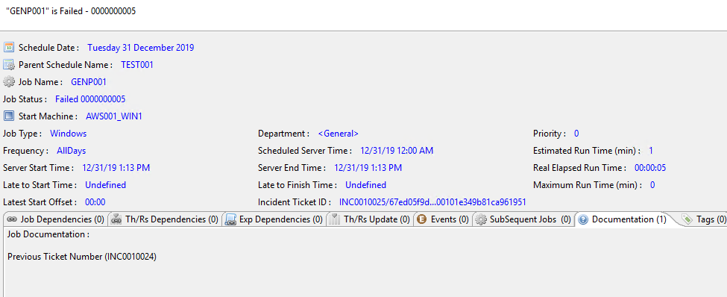

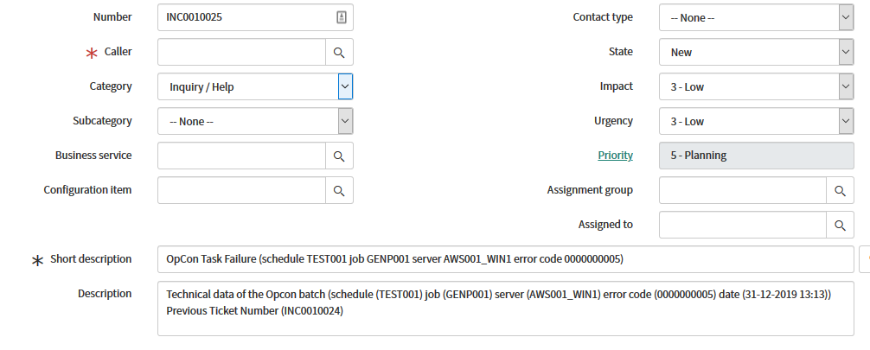

Figure 3 : Previous ticket number added to restart failures

When creating an incident ticket, the workflow name, the task name, the agent the task was executing on and the termination code are included in the incident description. The correlation_display field is used to indicate that the request is from OpCon (sets the value to SMA_OPCON) and the correlation_id field is used to provide the identifier of the task that errored (includes the OpCon Rest-API address and the unique job id) allowing the business rules in the SMA OpCon ServiceNow Application to complete task status changes.

1. The returned incident number and sys_id fields are written into the OpCon task in the task Incident Ticket ID field. If there was an existing ticket and a new ticket was created, the previous ticket number is written into the task documentation field.

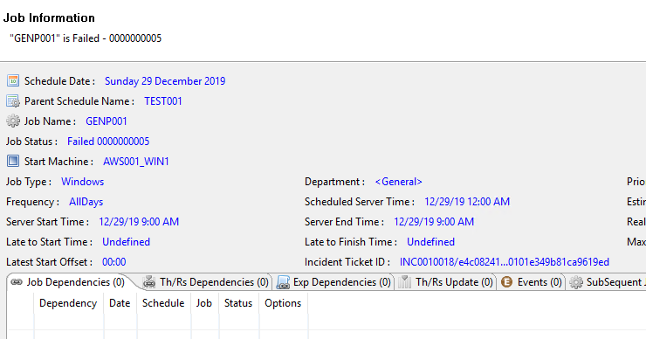

Figure 4 : Job Information example showing ServiceNow Incident number

1. The ServiceNow Connector calls the OpCon Rest-API to retrieve the task’s job log and attaches this to the created or existing ServiceNow Incident ticket.
2. The SMA OpCon ServiceNow Application, provides Business Rules that are triggered when the state of the Incident ticket is changed. These business rules then submit outbound Rest message calls to the OpCon Rest-API to change the task status. The correlation_display value is used to determine if the updated incident ticket is an OpCon ticket and the correlation_id values are inserted into the outbound Rest message to route the message to the correct OpCon system and task.

The following Business rules are provided:

* 1. OpConTicketAccepted triggered when the OpCon incident is updated and the

state changes from ‘New’ to ‘In Progress’. The OpCon task is set to the markUnderReview status indicating that the problem is being worked on.

* 1. OpConTicketResolved triggered when the OpCon incident is updated and the

state changes from ‘In Progress’ to ‘Resolved’. The OpCon task is set to the markFixed status indicating that the problem has been fixed. The task can then be restarted.

* 1. OpConTicketRelease an alternate rule that is triggered when the OpCon

incident is updated and the state changes from ‘In Progress’ to ‘Resolved’. The OpCon task is restarted.

* 1. OpConTicketCanceled triggered when the OpCon incident is updated and the

state changes to ‘Canceled’. The OpCon task is canceled.

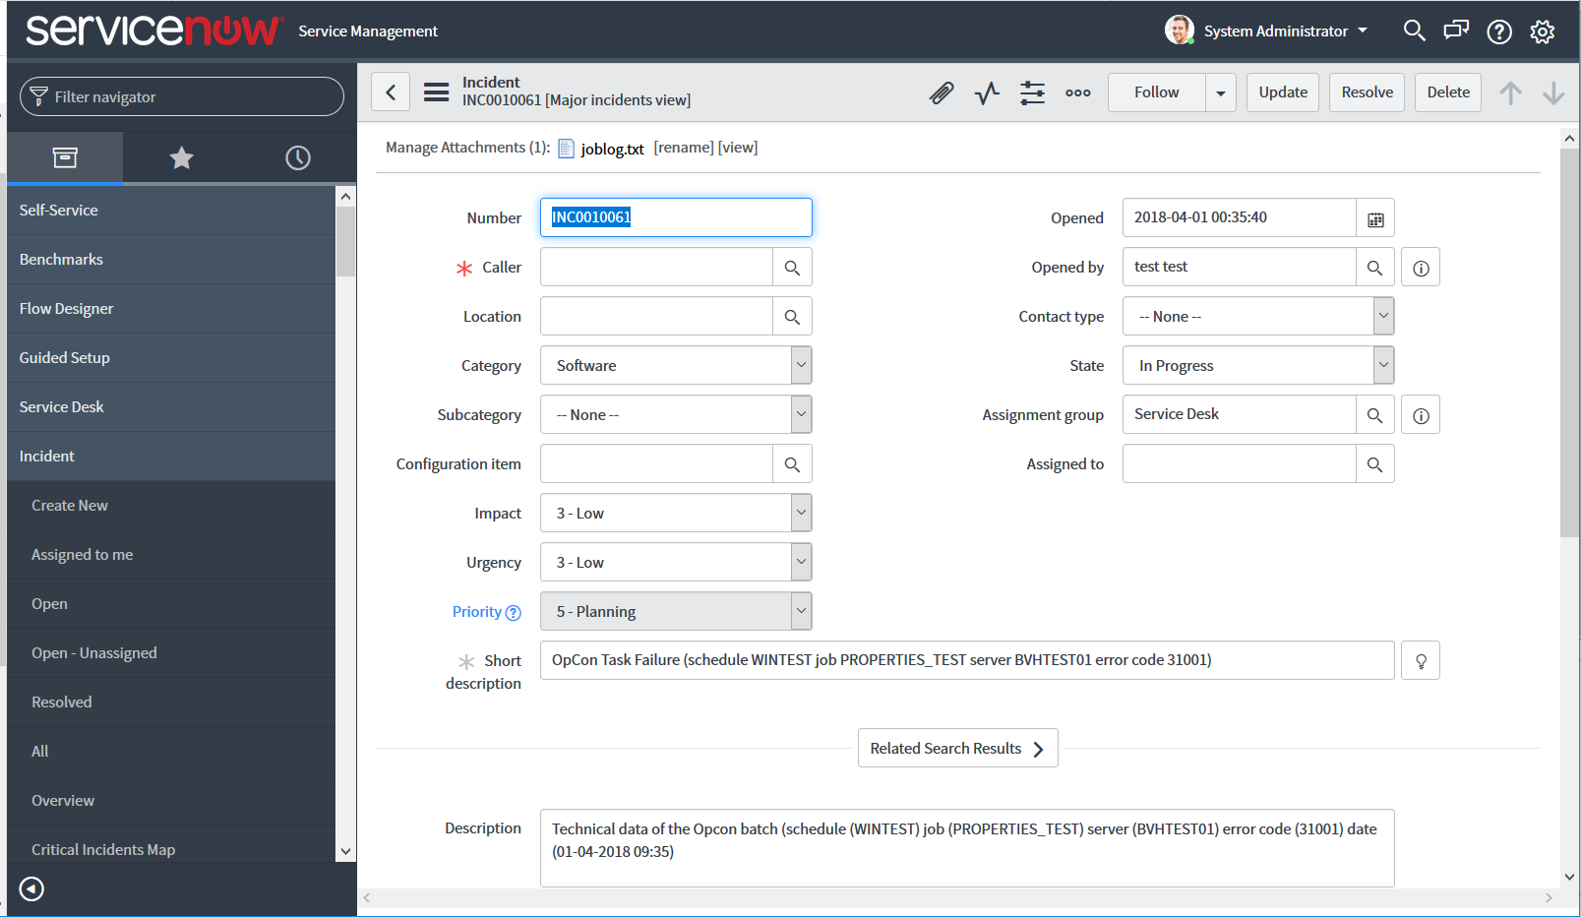

Figure 5 : ServiceNow example created Incident

Figure 5 shows an example of a created incident ticket. The short description and the description fields contain the workflow name, the task name, the agent name that was executing the task, the termination code and the date / time when the execution failed. The job log of the failed task can be accessed by double-clicking on the Manage Attachments in the upper left-hand corner.

# Installation

The ServiceNow SMA Application provides business rules and outbound Rest messages that can be imported into ServiceNow using the System Update Sets function.

## Supported Software Levels and Requirements

### OpCon ServiceNow Application

The application was developed using ServiceNow version Madrid.

### SMA OpCon Connector

The following software levels are required to implement the ServiceNow Connector.

* OpCon Release 19.0 or higher.
* OpCon RESTFul API Configured to not use TLS if self-signed certificates are being used.
* OpCon Windows Agent to provide link to ServiceNow Connector.
* OpCon Notification Manager.

## Installation

To import the ServiceNow SMA OpCon Application, got to Retrieved Update Sets and select the *Import Update Set from XML* button.

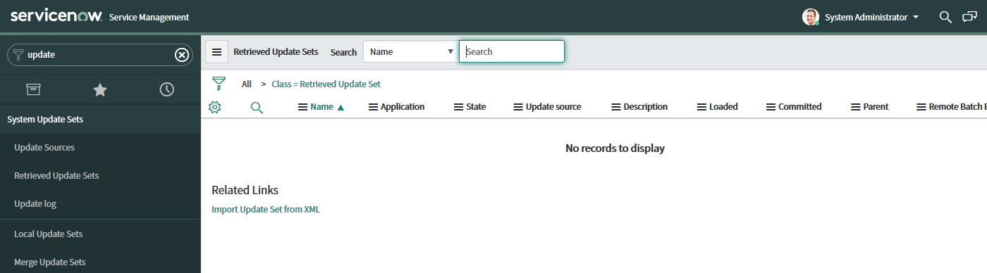

Figure 6 : Loading Application using System Update Sets

Now browse for the ServiceNow SMA OpCon Application file (should be in the application directory after connector installation).

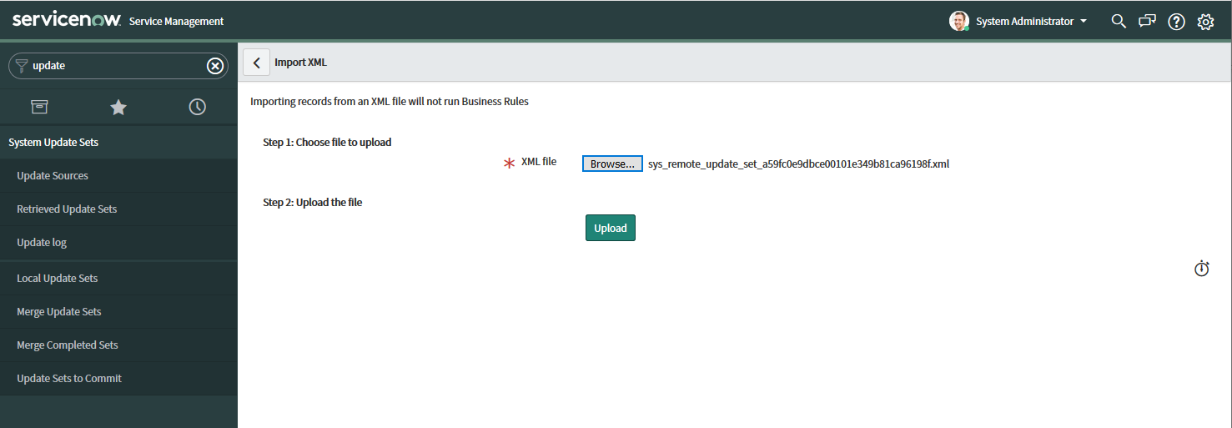

Figure 7 : Uploading Application File

Once the file has been found, select the *Upload* button.

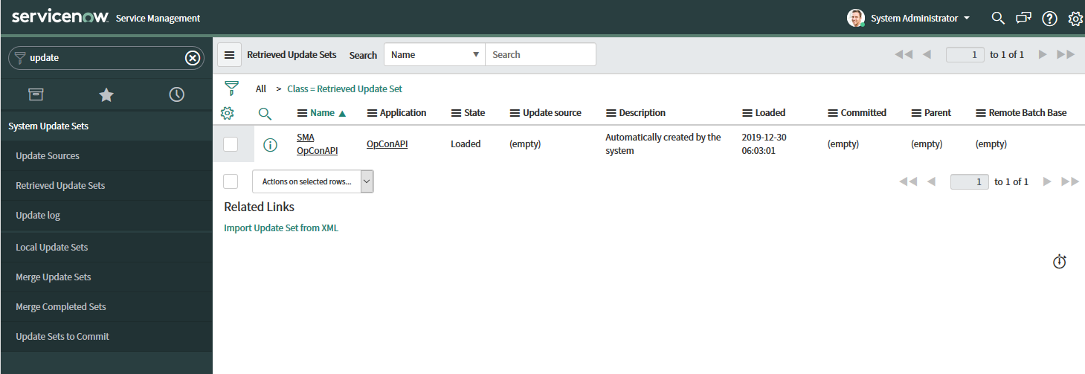

Figure 8 : Loaded Application on Retrieved Update Sets List

Once the upload is complete, the application will appear on the Retrieved Update Sets list. Select the application by ‘clicking’ on the name and the application information appears.

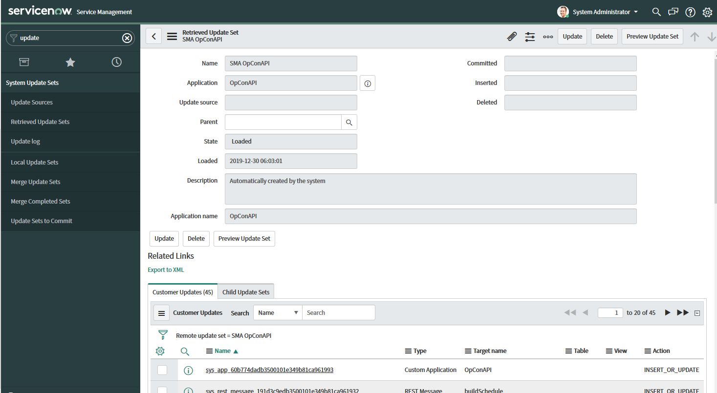

Figure 9 : ServiceNow SMA OpCon Application Information

Once the application information appears, select the Preview Update Set information. The process of previewing an Update Set detects problems that may occur if you commit the updates on the local instance. After you preview and before you commit an Update Set, follow this procedure to resolve all the problems that the preview process discovered. Once the indicates 100% succeeded, it is possible to commit the new application into the ServiceNow instance and make it available.

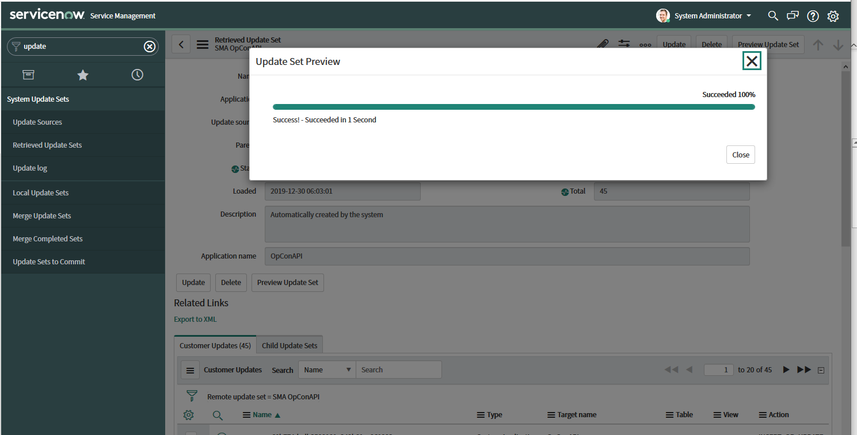

Figure 10 : Update Set Preview success

When the Update Preview Set had achieved a 100% success, the *Commit Update Set* button appears. Select this button to commit the update set and make it available in the ServiceNow instance.

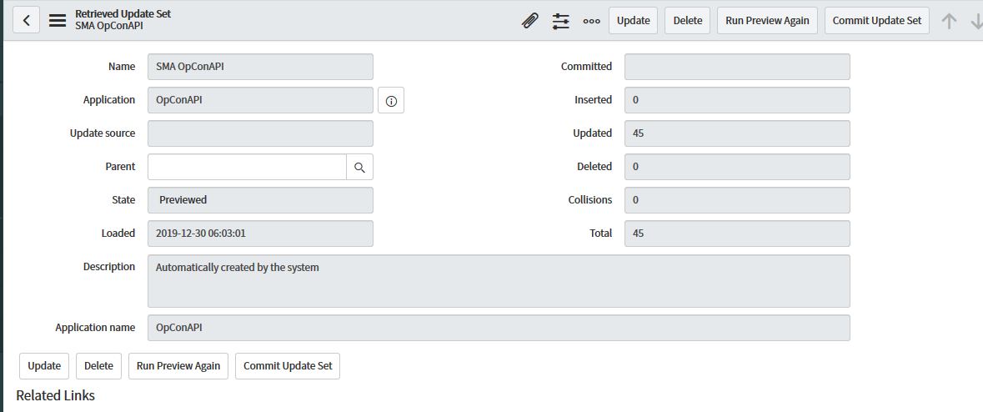

Figure 11 : Commit Update Set

Once the Update Set has been committed, the business rules and outbound rest messages are available in the ServiceNow instance. The business rules need to be marked as active to have any effect on the Incident table. Got to System Definition -> Business Rules and enter the name opcon in the search field and transmit. This will display the new installed rules.

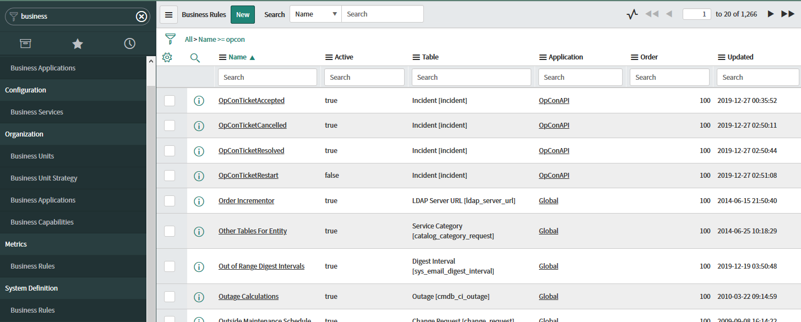

Figure 12 : Installed OpConAPI Business Rules

Select a rule and then mark the rule as Active for it to become effective.

The application import provided two rules that can be used when an Incident is Resolved. The task in OpCon can be set to Fixed (rule OpConTicketResolved) which means operations staff must release the task or it can be automatically restarted (rule OpConTicketRestart).

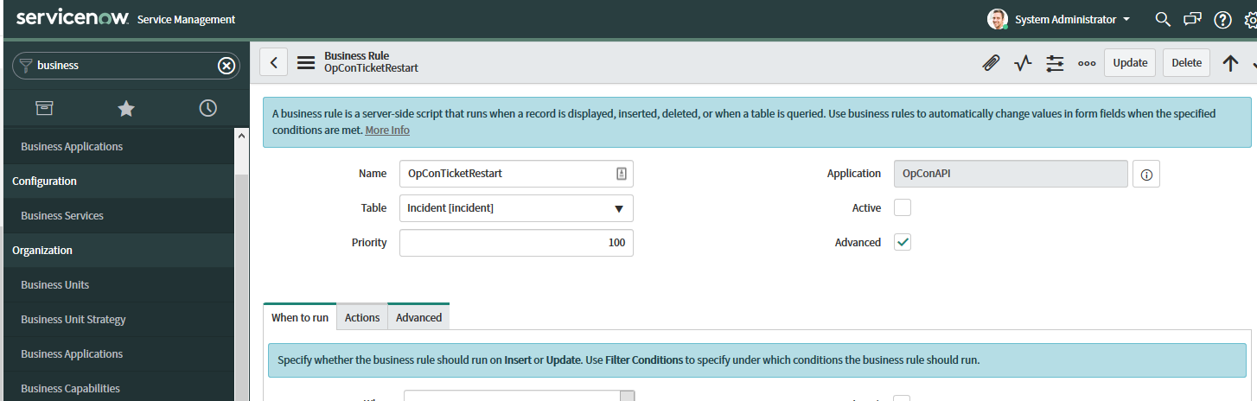

Figure 13 : Setting Business Rule to Active state.

Before using the business rules, the authentication header in the updateJobStatusByJobId rest message must be updated to include a valid OpCon application token.

First create the OpCon Application token (see OpCon-API documentation on how to create an application token). Once the application token has been created, update the Authorization header in the HTTP request of the select the updateJobStatusByJobId Outbound REST Message.

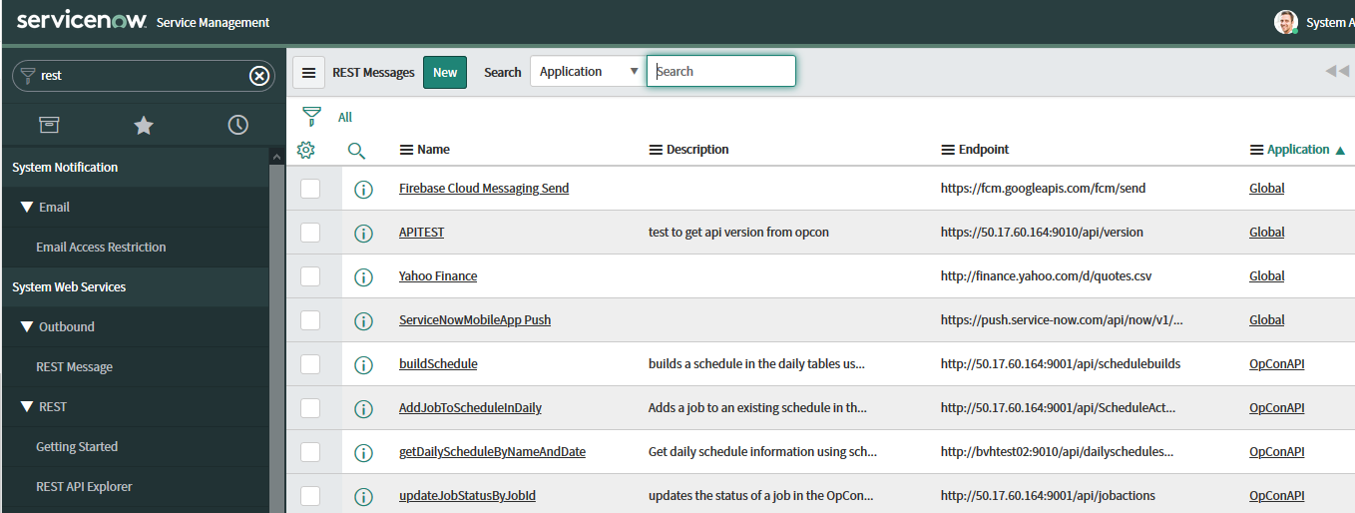

Figure 14 : Select updateJobStatusByJobId Rest Message

Once the REST Message has been retrieved, select the postStatus HTTP Method

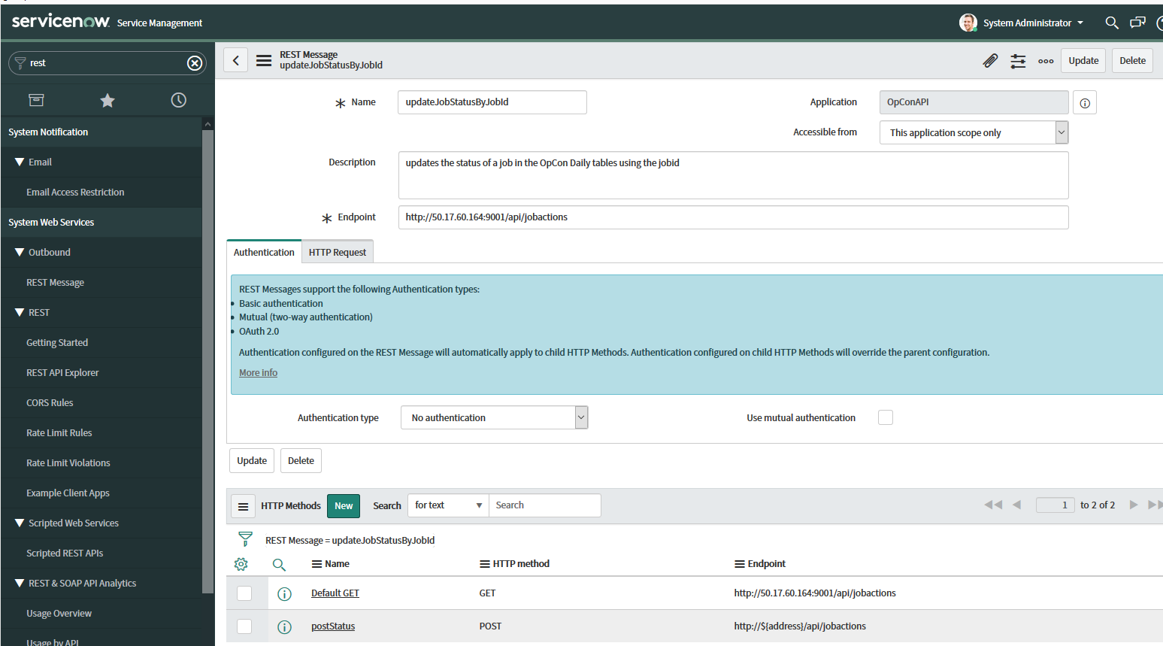

Figure 15 : updateJobStatusByJobId REST Message

Now update the Authorization header attribute replacing the token value. Remember to keep the leading Token<space> values.

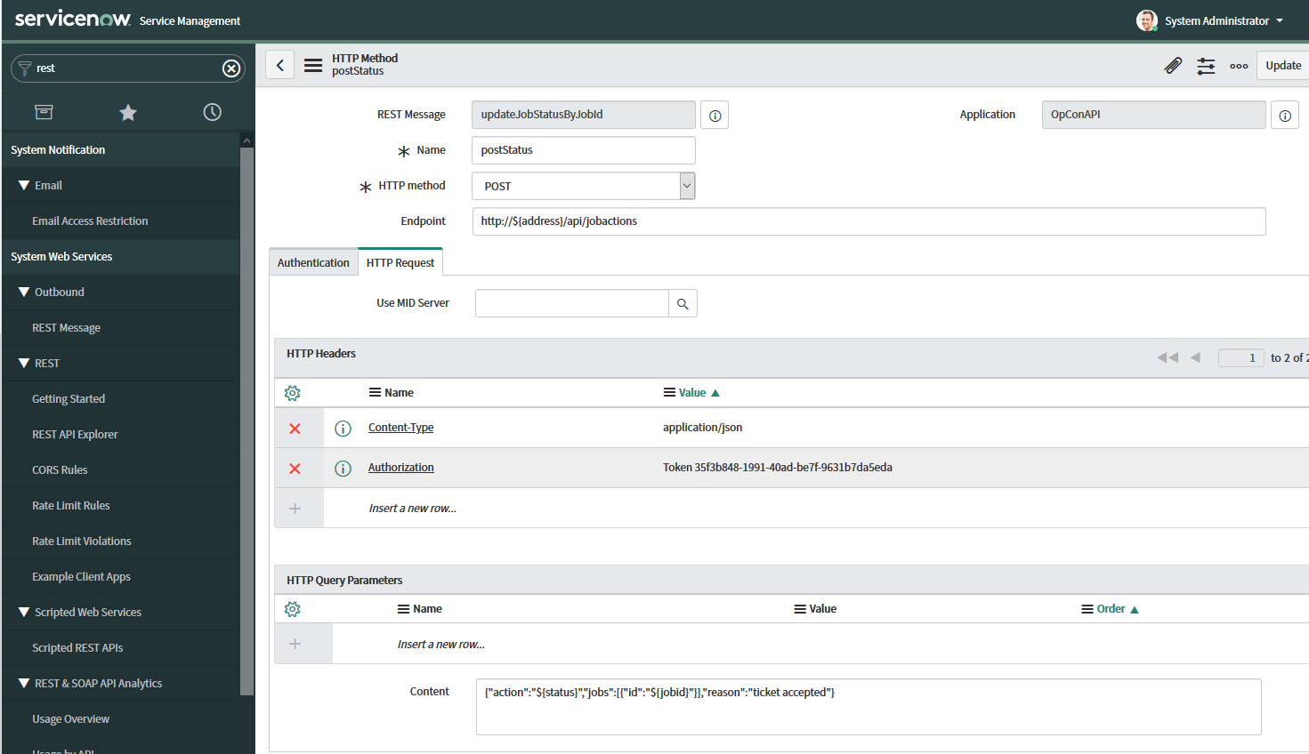

Figure 16 : Updating the Authentication header attribute